import pandas as pd  
  
# Step 1: Load the data  
df = pd.read_csv("WA_Fn-UseC_-Telco-Customer-Churn.csv")  
  
# Step 2: Preview the data  
print("First 5 rows:")  
print(df.head())  
  
# Step 3: Check dataset shape  
print("\nDataset shape:", df.shape)  
  
# Step 4: Check data types  
print("\nData types:")  
print(df.dtypes)  
  
# Step 5: Check for missing values  
print("\nMissing values per column:")  
print(df.isnull().sum())  
  
# Step 6: Check target variable distribution  
print("\nChurn value counts:")  
print(df['Churn'].value_counts())

First 5 rows:  
 customerID gender SeniorCitizen Partner Dependents tenure PhoneService \  
0 7590-VHVEG Female 0 Yes No 1 No   
1 5575-GNVDE Male 0 No No 34 Yes   
2 3668-QPYBK Male 0 No No 2 Yes   
3 7795-CFOCW Male 0 No No 45 No   
4 9237-HQITU Female 0 No No 2 Yes   
  
 MultipleLines InternetService OnlineSecurity ... DeviceProtection \  
0 No phone service DSL No ... No   
1 No DSL Yes ... Yes   
2 No DSL Yes ... No   
3 No phone service DSL Yes ... Yes   
4 No Fiber optic No ... No   
  
 TechSupport StreamingTV StreamingMovies Contract PaperlessBilling \  
0 No No No Month-to-month Yes   
1 No No No One year No   
2 No No No Month-to-month Yes   
3 Yes No No One year No   
4 No No No Month-to-month Yes   
  
 PaymentMethod MonthlyCharges TotalCharges Churn   
0 Electronic check 29.85 29.85 No   
1 Mailed check 56.95 1889.5 No   
2 Mailed check 53.85 108.15 Yes   
3 Bank transfer (automatic) 42.30 1840.75 No   
4 Electronic check 70.70 151.65 Yes   
  
[5 rows x 21 columns]  
  
Dataset shape: (7043, 21)  
  
Data types:  
customerID object  
gender object  
SeniorCitizen int64  
Partner object  
Dependents object  
tenure int64  
PhoneService object  
MultipleLines object  
InternetService object  
OnlineSecurity object  
OnlineBackup object  
DeviceProtection object  
TechSupport object  
StreamingTV object  
StreamingMovies object  
Contract object  
PaperlessBilling object  
PaymentMethod object  
MonthlyCharges float64  
TotalCharges object  
Churn object  
dtype: object  
  
Missing values per column:  
customerID 0  
gender 0  
SeniorCitizen 0  
Partner 0  
Dependents 0  
tenure 0  
PhoneService 0  
MultipleLines 0  
InternetService 0  
OnlineSecurity 0  
OnlineBackup 0  
DeviceProtection 0  
TechSupport 0  
StreamingTV 0  
StreamingMovies 0  
Contract 0  
PaperlessBilling 0  
PaymentMethod 0  
MonthlyCharges 0  
TotalCharges 0  
Churn 0  
dtype: int64  
  
Churn value counts:  
Churn  
No 5174  
Yes 1869  
Name: count, dtype: int64

import numpy as np  
  
# Step 1: Check why TotalCharges is object  
print("Unique problematic values in TotalCharges:")  
print(df.loc[df['TotalCharges'].str.strip() == '', 'TotalCharges'])  
  
# Step 2: Convert TotalCharges to numeric  
df['TotalCharges'] = pd.to_numeric(df['TotalCharges'], errors='coerce')  
  
# Step 3: Check how many NaNs appeared after conversion  
print("\nMissing TotalCharges after conversion:", df['TotalCharges'].isnull().sum())  
  
# Step 4: Drop rows with missing TotalCharges  
df = df.dropna(subset=['TotalCharges'])  
print("Shape after dropping missing TotalCharges:", df.shape)  
  
# Step 5: Drop customerID — not useful for modeling  
df = df.drop(columns=['customerID'])  
  
# Step 6: Sanity check categorical values  
for col in df.select_dtypes(include='object').columns:  
 print(f"Unique values in {col}: {df[col].unique()}")  
  
# Step 7: Strip whitespaces and standardize category names if needed  
df = df.applymap(lambda x: x.strip() if isinstance(x, str) else x)  
  
# Final check  
print("\nData types after cleaning:")  
print(df.dtypes)

Unique problematic values in TotalCharges:  
488   
753   
936   
1082   
1340   
3331   
3826   
4380   
5218   
6670   
6754   
Name: TotalCharges, dtype: object  
  
Missing TotalCharges after conversion: 11  
Shape after dropping missing TotalCharges: (7032, 21)  
Unique values in gender: ['Female' 'Male']  
Unique values in Partner: ['Yes' 'No']  
Unique values in Dependents: ['No' 'Yes']  
Unique values in PhoneService: ['No' 'Yes']  
Unique values in MultipleLines: ['No phone service' 'No' 'Yes']  
Unique values in InternetService: ['DSL' 'Fiber optic' 'No']  
Unique values in OnlineSecurity: ['No' 'Yes' 'No internet service']  
Unique values in OnlineBackup: ['Yes' 'No' 'No internet service']  
Unique values in DeviceProtection: ['No' 'Yes' 'No internet service']  
Unique values in TechSupport: ['No' 'Yes' 'No internet service']  
Unique values in StreamingTV: ['No' 'Yes' 'No internet service']  
Unique values in StreamingMovies: ['No' 'Yes' 'No internet service']  
Unique values in Contract: ['Month-to-month' 'One year' 'Two year']  
Unique values in PaperlessBilling: ['Yes' 'No']  
Unique values in PaymentMethod: ['Electronic check' 'Mailed check' 'Bank transfer (automatic)'  
 'Credit card (automatic)']  
Unique values in Churn: ['No' 'Yes']  
  
Data types after cleaning:  
gender object  
SeniorCitizen int64  
Partner object  
Dependents object  
tenure int64  
PhoneService object  
MultipleLines object  
InternetService object  
OnlineSecurity object  
OnlineBackup object  
DeviceProtection object  
TechSupport object  
StreamingTV object  
StreamingMovies object  
Contract object  
PaperlessBilling object  
PaymentMethod object  
MonthlyCharges float64  
TotalCharges float64  
Churn object  
dtype: object

C:\Users\danie\AppData\Local\Temp\ipykernel_18376\3136820042.py:25: FutureWarning: DataFrame.applymap has been deprecated. Use DataFrame.map instead.  
 df = df.applymap(lambda x: x.strip() if isinstance(x, str) else x)

# Step 1: Create Tenure Group  
def tenure_group(tenure):  
 if tenure <= 12:  
 return '0-1 year'  
 elif tenure <= 24:  
 return '1-2 years'  
 elif tenure <= 48:  
 return '2-4 years'  
 elif tenure <= 60:  
 return '4-5 years'  
 else:  
 return '5+ years'  
  
df['TenureGroup'] = df['tenure'].apply(tenure_group)  
  
# Step 2: Simplify categorical features  
# Convert 'No internet service' and 'No phone service' to 'No' for simplicity  
service_cols = ['MultipleLines', 'OnlineSecurity', 'OnlineBackup',  
 'DeviceProtection', 'TechSupport', 'StreamingTV', 'StreamingMovies']  
  
for col in service_cols:  
 df[col] = df[col].replace({'No internet service': 'No', 'No phone service': 'No'})  
  
# Step 3: Check updated category levels  
for col in service_cols + ['TenureGroup']:  
 print(f"Unique values in {col}: {df[col].unique()}")  
  
# Step 4: Drop original 'tenure' since we now have TenureGroup  
df.drop(columns=['tenure'], inplace=True)

Unique values in MultipleLines: ['No' 'Yes']  
Unique values in OnlineSecurity: ['No' 'Yes']  
Unique values in OnlineBackup: ['Yes' 'No']  
Unique values in DeviceProtection: ['No' 'Yes']  
Unique values in TechSupport: ['No' 'Yes']  
Unique values in StreamingTV: ['No' 'Yes']  
Unique values in StreamingMovies: ['No' 'Yes']  
Unique values in TenureGroup: ['0-1 year' '2-4 years' '1-2 years' '5+ years' '4-5 years']

from sklearn.model_selection import train_test_split  
  
# Step 1: Encode target variable  
df['Churn'] = df['Churn'].map({'No': 0, 'Yes': 1})  
  
# Step 2: One-hot encode categorical variables  
df_encoded = pd.get_dummies(df, drop_first=True) # Drop first to avoid dummy trap  
  
print("Shape after encoding:", df_encoded.shape)  
  
# Step 3: Define features (X) and target (y)  
X = df_encoded.drop(columns=['Churn'])  
y = df_encoded['Churn']  
  
# Step 4: Stratified train-test split (preserve churn proportion)  
X_train, X_test, y_train, y_test = train_test_split(  
 X, y, test_size=0.2, random_state=42, stratify=y)  
  
# Step 5: Sanity checks  
print("Training set shape:", X_train.shape)  
print("Test set shape:", X_test.shape)  
print("Churn rate in training set:", y_train.mean())  
print("Churn rate in test set:", y_test.mean())

Shape after encoding: (7032, 27)  
Training set shape: (5625, 26)  
Test set shape: (1407, 26)  
Churn rate in training set: 0.2657777777777778  
Churn rate in test set: 0.2658137882018479

from sklearn.linear_model import LogisticRegression  
from sklearn.metrics import classification_report, roc_auc_score, confusion_matrix  
  
# Initialize and train Logistic Regression  
baseline_lr = LogisticRegression(max_iter=1000, random_state=42, solver='liblinear')  
baseline_lr.fit(X_train, y_train)  
  
# Predictions  
y_pred_lr = baseline_lr.predict(X_test)  
y_proba_lr = baseline_lr.predict_proba(X_test)[:, 1]  
  
# Evaluation  
print("===== Logistic Regression (Baseline) =====")  
print(classification_report(y_test, y_pred_lr))  
print("ROC AUC:", roc_auc_score(y_test, y_proba_lr))  
print("Confusion Matrix:\n", confusion_matrix(y_test, y_pred_lr))

===== Logistic Regression (Baseline) =====  
 precision recall f1-score support  
  
 0 0.84 0.90 0.87 1033  
 1 0.65 0.52 0.58 374  
  
 accuracy 0.80 1407  
 macro avg 0.74 0.71 0.72 1407  
weighted avg 0.79 0.80 0.79 1407  
  
ROC AUC: 0.83180316921277  
Confusion Matrix:  
 [[930 103]  
 [181 193]]

from sklearn.ensemble import RandomForestClassifier  
  
# Initialize and train Random Forest  
baseline_rf = RandomForestClassifier(random_state=42)  
baseline_rf.fit(X_train, y_train)  
  
# Predictions  
y_pred_rf = baseline_rf.predict(X_test)  
y_proba_rf = baseline_rf.predict_proba(X_test)[:, 1]  
  
# Evaluation  
print("\n===== Random Forest (Baseline) =====")  
print(classification_report(y_test, y_pred_rf))  
print("ROC AUC:", roc_auc_score(y_test, y_proba_rf))  
print("Confusion Matrix:\n", confusion_matrix(y_test, y_pred_rf))

===== Random Forest (Baseline) =====  
 precision recall f1-score support  
  
 0 0.83 0.89 0.86 1033  
 1 0.61 0.49 0.55 374  
  
 accuracy 0.78 1407  
 macro avg 0.72 0.69 0.70 1407  
weighted avg 0.77 0.78 0.77 1407  
  
ROC AUC: 0.8133001330427445  
Confusion Matrix:  
 [[917 116]  
 [190 184]]

from imblearn.over_sampling import ADASYN  
  
# Initialize ADASYN  
adasyn = ADASYN(random_state=42)  
  
# Fit and resample  
X_resampled_adasyn, y_resampled_adasyn = adasyn.fit_resample(X_train, y_train)  
  
# Check new class distribution  
print("ADASYN resampled class distribution:")  
print(pd.Series(y_resampled_adasyn).value_counts())

ADASYN resampled class distribution:  
Churn  
1 4194  
0 4130  
Name: count, dtype: int64

from imblearn.under_sampling import TomekLinks  
  
# Initialize Tomek Links  
tomek = TomekLinks()  
  
# Apply Tomek Links *directly* to the original training set  
X_resampled_tomek, y_resampled_tomek = tomek.fit_resample(X_train, y_train)  
  
# Check new class distribution  
print("Tomek Links resampled class distribution:")  
print(pd.Series(y_resampled_tomek).value_counts())

Tomek Links resampled class distribution:  
Churn  
0 3680  
1 1495  
Name: count, dtype: int64

# Step 1: Apply ADASYN first  
X_resampled_hybrid, y_resampled_hybrid = adasyn.fit_resample(X_train, y_train)  
  
# Step 2: Apply Tomek Links *to the ADASYN-resampled data*  
X_resampled_hybrid_final, y_resampled_hybrid_final = tomek.fit_resample(  
 X_resampled_hybrid, y_resampled_hybrid)  
  
# Check new class distribution  
print("ADASYN + Tomek Links hybrid resampled class distribution:")  
print(pd.Series(y_resampled_hybrid_final).value_counts())

ADASYN + Tomek Links hybrid resampled class distribution:  
Churn  
0 4130  
1 3765  
Name: count, dtype: int64

from sklearn.metrics import classification_report, roc_auc_score, confusion_matrix  
  
def train_and_evaluate_model(model, X_train_resampled, y_train_resampled, X_test, y_test, model_name):  
 # Train  
 model.fit(X_train_resampled, y_train_resampled)  
  
 # Predict  
 y_pred = model.predict(X_test)  
 y_proba = model.predict_proba(X_test)[:, 1]  
  
 # Evaluation  
 print(f"\n===== {model_name} =====")  
 print(classification_report(y_test, y_pred))  
 print("ROC AUC:", roc_auc_score(y_test, y_proba))  
 print("Confusion Matrix:\n", confusion_matrix(y_test, y_pred))

# Initialize Logistic Regression  
lr = LogisticRegression(max_iter=1000, random_state=42, solver='liblinear')  
  
# ADASYN  
train_and_evaluate_model(lr, X_resampled_adasyn, y_resampled_adasyn, X_test, y_test, "Logistic Regression (ADASYN)")  
  
# Tomek Links  
train_and_evaluate_model(lr, X_resampled_tomek, y_resampled_tomek, X_test, y_test, "Logistic Regression (Tomek Links)")  
  
# Hybrid  
train_and_evaluate_model(lr, X_resampled_hybrid_final, y_resampled_hybrid_final, X_test, y_test, "Logistic Regression (ADASYN + Tomek)")

===== Logistic Regression (ADASYN) =====  
 precision recall f1-score support  
  
 0 0.85 0.80 0.82 1033  
 1 0.52 0.61 0.57 374  
  
 accuracy 0.75 1407  
 macro avg 0.69 0.71 0.69 1407  
weighted avg 0.76 0.75 0.75 1407  
  
ROC AUC: 0.7829914945825202  
Confusion Matrix:  
 [[823 210]  
 [144 230]]  
  
===== Logistic Regression (Tomek Links) =====  
 precision recall f1-score support  
  
 0 0.86 0.86 0.86 1033  
 1 0.61 0.61 0.61 374  
  
 accuracy 0.79 1407  
 macro avg 0.74 0.74 0.74 1407  
weighted avg 0.79 0.79 0.79 1407  
  
ROC AUC: 0.8304727417676566  
Confusion Matrix:  
 [[888 145]  
 [145 229]]  
  
===== Logistic Regression (ADASYN + Tomek) =====  
 precision recall f1-score support  
  
 0 0.85 0.83 0.84 1033  
 1 0.55 0.58 0.57 374  
  
 accuracy 0.76 1407  
 macro avg 0.70 0.70 0.70 1407  
weighted avg 0.77 0.76 0.76 1407  
  
ROC AUC: 0.7806826594053973  
Confusion Matrix:  
 [[854 179]  
 [156 218]]

# Initialize Random Forest  
rf = RandomForestClassifier(random_state=42)  
  
# ADASYN  
train_and_evaluate_model(rf, X_resampled_adasyn, y_resampled_adasyn, X_test, y_test, "Random Forest (ADASYN)")  
  
# Tomek Links  
train_and_evaluate_model(rf, X_resampled_tomek, y_resampled_tomek, X_test, y_test, "Random Forest (Tomek Links)")  
  
# Hybrid  
train_and_evaluate_model(rf, X_resampled_hybrid_final, y_resampled_hybrid_final, X_test, y_test, "Random Forest (ADASYN + Tomek)")

===== Random Forest (ADASYN) =====  
 precision recall f1-score support  
  
 0 0.85 0.83 0.84 1033  
 1 0.56 0.59 0.57 374  
  
 accuracy 0.77 1407  
 macro avg 0.70 0.71 0.71 1407  
weighted avg 0.77 0.77 0.77 1407  
  
ROC AUC: 0.8072950908780303  
Confusion Matrix:  
 [[856 177]  
 [153 221]]  
  
===== Random Forest (Tomek Links) =====  
 precision recall f1-score support  
  
 0 0.85 0.85 0.85 1033  
 1 0.59 0.60 0.60 374  
  
 accuracy 0.78 1407  
 macro avg 0.72 0.72 0.72 1407  
weighted avg 0.78 0.78 0.78 1407  
  
ROC AUC: 0.8200130972040317  
Confusion Matrix:  
 [[881 152]  
 [151 223]]  
  
===== Random Forest (ADASYN + Tomek) =====  
 precision recall f1-score support  
  
 0 0.84 0.83 0.84 1033  
 1 0.55 0.56 0.56 374  
  
 accuracy 0.76 1407  
 macro avg 0.70 0.70 0.70 1407  
weighted avg 0.76 0.76 0.76 1407  
  
ROC AUC: 0.8098990014029022  
Confusion Matrix:  
 [[861 172]  
 [163 211]]

from sklearn.feature_selection import RFE  
from sklearn.linear_model import LogisticRegression  
  
def perform_rfe(X, y, n_features):  
 # Create a Logistic Regression model (solver liblinear for small datasets)  
 model = LogisticRegression(max_iter=1000, random_state=42, solver='liblinear')  
  
 # Recursive Feature Elimination  
 rfe = RFE(model, n_features_to_select=n_features)  
 rfe.fit(X, y)  
  
 # Get selected feature names  
 selected_features = X.columns[rfe.support_].tolist()  
 return selected_features

# Let's select 10 features to keep things simple and prevent overfitting  
n_features = 10

# ADASYN  
features_adasyn = perform_rfe(X_resampled_adasyn, y_resampled_adasyn, n_features)  
print("\nSelected features for ADASYN:", features_adasyn)  
  
# Tomek Links  
features_tomek = perform_rfe(X_resampled_tomek, y_resampled_tomek, n_features)  
print("\nSelected features for Tomek Links:", features_tomek)  
  
# ADASYN + Tomek Hybrid  
features_hybrid = perform_rfe(X_resampled_hybrid_final, y_resampled_hybrid_final, n_features)  
print("\nSelected features for ADASYN + Tomek Links hybrid:", features_hybrid)

Selected features for ADASYN: ['gender_Male', 'InternetService_Fiber optic', 'StreamingMovies_Yes', 'Contract_One year', 'Contract_Two year', 'PaperlessBilling_Yes', 'PaymentMethod_Credit card (automatic)', 'PaymentMethod_Electronic check', 'PaymentMethod_Mailed check', 'TenureGroup_5+ years']  
  
Selected features for Tomek Links: ['InternetService_Fiber optic', 'InternetService_No', 'OnlineSecurity_Yes', 'Contract_One year', 'Contract_Two year', 'PaymentMethod_Electronic check', 'TenureGroup_1-2 years', 'TenureGroup_2-4 years', 'TenureGroup_4-5 years', 'TenureGroup_5+ years']  
  
Selected features for ADASYN + Tomek Links hybrid: ['gender_Male', 'InternetService_Fiber optic', 'StreamingMovies_Yes', 'Contract_One year', 'Contract_Two year', 'PaperlessBilling_Yes', 'PaymentMethod_Credit card (automatic)', 'PaymentMethod_Electronic check', 'PaymentMethod_Mailed check', 'TenureGroup_5+ years']

# Subset for ADASYN  
X_adasyn_rfe = X_resampled_adasyn[features_adasyn]  
  
# Subset for Tomek Links  
X_tomek_rfe = X_resampled_tomek[features_tomek]  
  
# Subset for ADASYN + Tomek Hybrid  
X_hybrid_rfe = X_resampled_hybrid_final[features_hybrid]  
  
# Also subset the test set for fair comparison  
X_test_adasyn = X_test[features_adasyn]  
X_test_tomek = X_test[features_tomek]  
X_test_hybrid = X_test[features_hybrid]

def train_and_evaluate_model(model, X_train_resampled, y_train_resampled, X_test, y_test, model_name):  
 model.fit(X_train_resampled, y_train_resampled)  
  
 y_pred = model.predict(X_test)  
 y_proba = model.predict_proba(X_test)[:, 1]  
  
 print(f"\n===== {model_name} =====")  
 print(classification_report(y_test, y_pred))  
 print("ROC AUC:", roc_auc_score(y_test, y_proba))  
 print("Confusion Matrix:\n", confusion_matrix(y_test, y_pred))

# Logistic Regression model  
lr = LogisticRegression(max_iter=1000, random_state=42, solver='liblinear')  
  
# ADASYN  
train_and_evaluate_model(lr, X_adasyn_rfe, y_resampled_adasyn, X_test_adasyn, y_test, "Logistic Regression (ADASYN + RFE)")  
  
# Tomek  
train_and_evaluate_model(lr, X_tomek_rfe, y_resampled_tomek, X_test_tomek, y_test, "Logistic Regression (Tomek + RFE)")  
  
# Hybrid  
train_and_evaluate_model(lr, X_hybrid_rfe, y_resampled_hybrid_final, X_test_hybrid, y_test, "Logistic Regression (Hybrid + RFE)")

===== Logistic Regression (ADASYN + RFE) =====  
 precision recall f1-score support  
  
 0 0.85 0.72 0.78 1033  
 1 0.46 0.66 0.54 374  
  
 accuracy 0.71 1407  
 macro avg 0.66 0.69 0.66 1407  
weighted avg 0.75 0.71 0.72 1407  
  
ROC AUC: 0.7665902231701446  
Confusion Matrix:  
 [[748 285]  
 [129 245]]  
  
===== Logistic Regression (Tomek + RFE) =====  
 precision recall f1-score support  
  
 0 0.85 0.85 0.85 1033  
 1 0.59 0.59 0.59 374  
  
 accuracy 0.78 1407  
 macro avg 0.72 0.72 0.72 1407  
weighted avg 0.78 0.78 0.78 1407  
  
ROC AUC: 0.8270094890019722  
Confusion Matrix:  
 [[882 151]  
 [153 221]]  
  
===== Logistic Regression (Hybrid + RFE) =====  
 precision recall f1-score support  
  
 0 0.84 0.75 0.79 1033  
 1 0.47 0.61 0.53 374  
  
 accuracy 0.71 1407  
 macro avg 0.65 0.68 0.66 1407  
weighted avg 0.74 0.71 0.72 1407  
  
ROC AUC: 0.7680293625854813  
Confusion Matrix:  
 [[773 260]  
 [147 227]]

# Random Forest model  
rf = RandomForestClassifier(random_state=42)  
  
# ADASYN  
train_and_evaluate_model(rf, X_adasyn_rfe, y_resampled_adasyn, X_test_adasyn, y_test, "Random Forest (ADASYN + RFE)")  
  
# Tomek  
train_and_evaluate_model(rf, X_tomek_rfe, y_resampled_tomek, X_test_tomek, y_test, "Random Forest (Tomek + RFE)")  
  
# Hybrid  
train_and_evaluate_model(rf, X_hybrid_rfe, y_resampled_hybrid_final, X_test_hybrid, y_test, "Random Forest (Hybrid + RFE)")

===== Random Forest (ADASYN + RFE) =====  
 precision recall f1-score support  
  
 0 0.86 0.74 0.79 1033  
 1 0.48 0.66 0.56 374  
  
 accuracy 0.72 1407  
 macro avg 0.67 0.70 0.68 1407  
weighted avg 0.76 0.72 0.73 1407  
  
ROC AUC: 0.7754308358915158  
Confusion Matrix:  
 [[765 268]  
 [127 247]]  
  
===== Random Forest (Tomek + RFE) =====  
 precision recall f1-score support  
  
 0 0.84 0.87 0.86 1033  
 1 0.61 0.54 0.57 374  
  
 accuracy 0.78 1407  
 macro avg 0.72 0.71 0.71 1407  
weighted avg 0.78 0.78 0.78 1407  
  
ROC AUC: 0.819914738754782  
Confusion Matrix:  
 [[903 130]  
 [173 201]]  
  
===== Random Forest (Hybrid + RFE) =====  
 precision recall f1-score support  
  
 0 0.86 0.75 0.80 1033  
 1 0.49 0.66 0.56 374  
  
 accuracy 0.72 1407  
 macro avg 0.67 0.70 0.68 1407  
weighted avg 0.76 0.72 0.74 1407  
  
ROC AUC: 0.7792512851307908  
Confusion Matrix:  
 [[774 259]  
 [129 245]]

from sklearn.model_selection import GridSearchCV  
  
# Define parameter grid  
lr_param_grid = {  
 'penalty': ['l1', 'l2'],  
 'C': [0.01, 0.1, 1, 10, 100],  
 'solver': ['liblinear']  
}  
  
# Initialize model  
lr = LogisticRegression(max_iter=1000, random_state=42)  
  
# Tomek + RFE  
grid_lr_tomek = GridSearchCV(lr, lr_param_grid, scoring='f1', cv=5)  
grid_lr_tomek.fit(X_tomek_rfe, y_resampled_tomek)  
  
print("Best LR params (Tomek):", grid_lr_tomek.best_params_)  
  
# ADASYN + RFE  
grid_lr_adasyn = GridSearchCV(lr, lr_param_grid, scoring='f1', cv=5)  
grid_lr_adasyn.fit(X_adasyn_rfe, y_resampled_adasyn)  
  
print("Best LR params (ADASYN):", grid_lr_adasyn.best_params_)

Best LR params (Tomek): {'C': 0.1, 'penalty': 'l1', 'solver': 'liblinear'}  
Best LR params (ADASYN): {'C': 0.01, 'penalty': 'l2', 'solver': 'liblinear'}

rf_param_grid = {  
 'n_estimators': [100, 200],  
 'max_depth': [None, 10, 20, 30],  
 'min_samples_split': [2, 5, 10],  
 'min_samples_leaf': [1, 2, 4],  
 'max_features': ['sqrt', 'log2']  
}  
  
rf = RandomForestClassifier(random_state=42)  
  
# Tomek + RFE  
grid_rf_tomek = GridSearchCV(rf, rf_param_grid, scoring='f1', cv=5)  
grid_rf_tomek.fit(X_tomek_rfe, y_resampled_tomek)  
  
print("Best RF params (Tomek):", grid_rf_tomek.best_params_)  
  
# ADASYN + RFE  
grid_rf_adasyn = GridSearchCV(rf, rf_param_grid, scoring='f1', cv=5)  
grid_rf_adasyn.fit(X_adasyn_rfe, y_resampled_adasyn)  
  
print("Best RF params (ADASYN):", grid_rf_adasyn.best_params_)

Best RF params (Tomek): {'max_depth': None, 'max_features': 'sqrt', 'min_samples_leaf': 4, 'min_samples_split': 2, 'n_estimators': 200}  
Best RF params (ADASYN): {'max_depth': None, 'max_features': 'sqrt', 'min_samples_leaf': 1, 'min_samples_split': 5, 'n_estimators': 100}

# Logistic Regression with Tomek  
lr_tomek = LogisticRegression(C=0.1, penalty='l1', solver='liblinear', max_iter=1000, random_state=42)  
train_and_evaluate_model(lr_tomek, X_tomek_rfe, y_resampled_tomek, X_test_tomek, y_test, "Logistic Regression (Tomek + RFE + Tuned)")  
  
# Logistic Regression with ADASYN  
lr_adasyn = LogisticRegression(C=0.01, penalty='l2', solver='liblinear', max_iter=1000, random_state=42)  
train_and_evaluate_model(lr_adasyn, X_adasyn_rfe, y_resampled_adasyn, X_test_adasyn, y_test, "Logistic Regression (ADASYN + RFE + Tuned)")

===== Logistic Regression (Tomek + RFE + Tuned) =====  
 precision recall f1-score support  
  
 0 0.85 0.86 0.85 1033  
 1 0.60 0.59 0.59 374  
  
 accuracy 0.79 1407  
 macro avg 0.72 0.72 0.72 1407  
weighted avg 0.78 0.79 0.78 1407  
  
ROC AUC: 0.825956018242904  
Confusion Matrix:  
 [[884 149]  
 [153 221]]  
  
===== Logistic Regression (ADASYN + RFE + Tuned) =====  
 precision recall f1-score support  
  
 0 0.87 0.69 0.77 1033  
 1 0.46 0.71 0.55 374  
  
 accuracy 0.70 1407  
 macro avg 0.66 0.70 0.66 1407  
weighted avg 0.76 0.70 0.71 1407  
  
ROC AUC: 0.7852291493029492  
Confusion Matrix:  
 [[717 316]  
 [110 264]]

# Random Forest with Tomek  
rf_tomek = RandomForestClassifier(  
 n_estimators=200,  
 max_depth=None,  
 max_features='sqrt',  
 min_samples_leaf=4,  
 min_samples_split=2,  
 random_state=42  
)  
train_and_evaluate_model(rf_tomek, X_tomek_rfe, y_resampled_tomek, X_test_tomek, y_test, "Random Forest (Tomek + RFE + Tuned)")  
  
# Random Forest with ADASYN  
rf_adasyn = RandomForestClassifier(  
 n_estimators=100,  
 max_depth=None,  
 max_features='sqrt',  
 min_samples_leaf=1,  
 min_samples_split=5,  
 random_state=42  
)  
train_and_evaluate_model(rf_adasyn, X_adasyn_rfe, y_resampled_adasyn, X_test_adasyn, y_test, "Random Forest (ADASYN + RFE + Tuned)")

===== Random Forest (Tomek + RFE + Tuned) =====  
 precision recall f1-score support  
  
 0 0.84 0.88 0.86 1033  
 1 0.61 0.53 0.57 374  
  
 accuracy 0.79 1407  
 macro avg 0.73 0.71 0.71 1407  
weighted avg 0.78 0.79 0.78 1407  
  
ROC AUC: 0.822491471287098  
Confusion Matrix:  
 [[907 126]  
 [174 200]]  
  
===== Random Forest (ADASYN + RFE + Tuned) =====  
 precision recall f1-score support  
  
 0 0.86 0.74 0.80 1033  
 1 0.48 0.66 0.56 374  
  
 accuracy 0.72 1407  
 macro avg 0.67 0.70 0.68 1407  
weighted avg 0.76 0.72 0.73 1407  
  
ROC AUC: 0.7781266339150286  
Confusion Matrix:  
 [[766 267]  
 [127 247]]

import numpy as np  
from sklearn.metrics import precision_recall_fscore_support  
  
# Predict probabilities  
y_proba_lr_tomek = lr_tomek.predict_proba(X_test_tomek)[:, 1]  
  
# Define thresholds to test  
thresholds = np.arange(0.3, 0.71, 0.01)  
  
print("Threshold | Precision | Recall | F1")  
for thresh in thresholds:  
 y_pred_thresh = (y_proba_lr_tomek >= thresh).astype(int)  
 precision, recall, f1, _ = precision_recall_fscore_support(y_test, y_pred_thresh, average='binary')  
 print(f"{thresh:.2f} | {precision:.2f} | {recall:.2f} | {f1:.2f}")

Threshold | Precision | Recall | F1  
0.30 | 0.47 | 0.81 | 0.60  
0.31 | 0.48 | 0.80 | 0.60  
0.32 | 0.49 | 0.78 | 0.60  
0.33 | 0.52 | 0.77 | 0.62  
0.34 | 0.52 | 0.77 | 0.62  
0.35 | 0.52 | 0.77 | 0.62  
0.36 | 0.52 | 0.76 | 0.62  
0.37 | 0.52 | 0.76 | 0.62  
0.38 | 0.52 | 0.76 | 0.62  
0.39 | 0.52 | 0.76 | 0.62  
0.40 | 0.53 | 0.75 | 0.62  
0.41 | 0.53 | 0.74 | 0.62  
0.42 | 0.53 | 0.74 | 0.62  
0.43 | 0.53 | 0.72 | 0.61  
0.44 | 0.55 | 0.68 | 0.61  
0.45 | 0.55 | 0.68 | 0.61  
0.46 | 0.59 | 0.59 | 0.59  
0.47 | 0.59 | 0.59 | 0.59  
0.48 | 0.60 | 0.59 | 0.59  
0.49 | 0.60 | 0.59 | 0.59  
0.50 | 0.60 | 0.59 | 0.59  
0.51 | 0.60 | 0.59 | 0.59  
0.52 | 0.60 | 0.59 | 0.59  
0.53 | 0.60 | 0.58 | 0.59  
0.54 | 0.62 | 0.54 | 0.58  
0.55 | 0.62 | 0.54 | 0.58  
0.56 | 0.64 | 0.45 | 0.53  
0.57 | 0.66 | 0.40 | 0.50  
0.58 | 0.66 | 0.39 | 0.49  
0.59 | 0.66 | 0.39 | 0.49  
0.60 | 0.66 | 0.39 | 0.49  
0.61 | 0.66 | 0.39 | 0.49  
0.62 | 0.66 | 0.39 | 0.49  
0.63 | 0.66 | 0.39 | 0.49  
0.64 | 0.66 | 0.39 | 0.49  
0.65 | 0.66 | 0.39 | 0.49  
0.66 | 0.68 | 0.32 | 0.44  
0.67 | 0.68 | 0.32 | 0.44  
0.68 | 0.68 | 0.32 | 0.44  
0.69 | 0.67 | 0.31 | 0.42  
0.70 | 0.68 | 0.21 | 0.33

y_proba_rf_adasyn = rf_adasyn.predict_proba(X_test_adasyn)[:, 1]  
  
print("\nThreshold | Precision | Recall | F1")  
for thresh in thresholds:  
 y_pred_thresh = (y_proba_rf_adasyn >= thresh).astype(int)  
 precision, recall, f1, _ = precision_recall_fscore_support(y_test, y_pred_thresh, average='binary')  
 print(f"{thresh:.2f} | {precision:.2f} | {recall:.2f} | {f1:.2f}")

Threshold | Precision | Recall | F1  
0.30 | 0.40 | 0.86 | 0.55  
0.31 | 0.40 | 0.86 | 0.55  
0.32 | 0.40 | 0.86 | 0.55  
0.33 | 0.41 | 0.84 | 0.55  
0.34 | 0.43 | 0.82 | 0.56  
0.35 | 0.43 | 0.82 | 0.57  
0.36 | 0.43 | 0.82 | 0.57  
0.37 | 0.43 | 0.82 | 0.57  
0.38 | 0.44 | 0.82 | 0.57  
0.39 | 0.44 | 0.82 | 0.57  
0.40 | 0.44 | 0.81 | 0.57  
0.41 | 0.44 | 0.78 | 0.56  
0.42 | 0.44 | 0.78 | 0.56  
0.43 | 0.44 | 0.73 | 0.55  
0.44 | 0.44 | 0.73 | 0.55  
0.45 | 0.44 | 0.73 | 0.55  
0.46 | 0.45 | 0.70 | 0.55  
0.47 | 0.45 | 0.69 | 0.55  
0.48 | 0.47 | 0.67 | 0.55  
0.49 | 0.48 | 0.66 | 0.56  
0.50 | 0.48 | 0.66 | 0.56  
0.51 | 0.48 | 0.65 | 0.55  
0.52 | 0.48 | 0.65 | 0.55  
0.53 | 0.48 | 0.65 | 0.55  
0.54 | 0.49 | 0.65 | 0.56  
0.55 | 0.49 | 0.65 | 0.56  
0.56 | 0.49 | 0.62 | 0.55  
0.57 | 0.50 | 0.61 | 0.55  
0.58 | 0.50 | 0.58 | 0.54  
0.59 | 0.50 | 0.56 | 0.53  
0.60 | 0.50 | 0.54 | 0.52  
0.61 | 0.51 | 0.53 | 0.52  
0.62 | 0.55 | 0.48 | 0.51  
0.63 | 0.55 | 0.48 | 0.51  
0.64 | 0.57 | 0.48 | 0.52  
0.65 | 0.57 | 0.46 | 0.51  
0.66 | 0.57 | 0.44 | 0.50  
0.67 | 0.58 | 0.40 | 0.48  
0.68 | 0.58 | 0.40 | 0.47  
0.69 | 0.58 | 0.40 | 0.47  
0.70 | 0.58 | 0.39 | 0.47

# Logistic Regression - Tomek  
lr_tomek = LogisticRegression(C=0.1, penalty='l1', solver='liblinear', max_iter=1000, random_state=42)  
lr_tomek.fit(X_tomek_rfe, y_resampled_tomek)  
  
# Random Forest - ADASYN  
rf_adasyn = RandomForestClassifier(  
 n_estimators=100,  
 max_depth=None,  
 max_features='sqrt',  
 min_samples_leaf=1,  
 min_samples_split=5,  
 random_state=42  
)  
rf_adasyn.fit(X_adasyn_rfe, y_resampled_adasyn)

RandomForestClassifier(min_samples_split=5, random_state=42)

from sklearn.metrics import classification_report, roc_auc_score, confusion_matrix  
  
def evaluate_with_threshold_full_report(model, X_test, y_test, threshold, model_name):  
 y_proba = model.predict_proba(X_test)[:, 1]  
 y_pred = (y_proba >= threshold).astype(int)  
  
 print(f"\n===== {model_name} =====")  
 print("Threshold:", threshold)  
 print(classification_report(y_test, y_pred))  
 print("ROC AUC:", round(roc_auc_score(y_test, y_proba), 3))  
 print("Confusion Matrix:\n", confusion_matrix(y_test, y_pred))

# Logistic Regression - Tomek (Threshold 0.34)  
evaluate_with_threshold_full_report(lr_tomek, X_test_tomek, y_test, 0.34, "Logistic Regression (Tomek + RFE + Tuned)")  
  
# Random Forest - ADASYN (Threshold 0.35)  
evaluate_with_threshold_full_report(rf_adasyn, X_test_adasyn, y_test, 0.35, "Random Forest (ADASYN + RFE + Tuned)")

===== Logistic Regression (Tomek + RFE + Tuned) =====  
Threshold: 0.34  
 precision recall f1-score support  
  
 0 0.90 0.74 0.81 1033  
 1 0.52 0.77 0.62 374  
  
 accuracy 0.75 1407  
 macro avg 0.71 0.76 0.72 1407  
weighted avg 0.80 0.75 0.76 1407  
  
ROC AUC: 0.826  
Confusion Matrix:  
 [[764 269]  
 [ 85 289]]  
  
===== Random Forest (ADASYN + RFE + Tuned) =====  
Threshold: 0.35  
 precision recall f1-score support  
  
 0 0.91 0.61 0.73 1033  
 1 0.43 0.82 0.57 374  
  
 accuracy 0.67 1407  
 macro avg 0.67 0.72 0.65 1407  
weighted avg 0.78 0.67 0.69 1407  
  
ROC AUC: 0.778  
Confusion Matrix:  
 [[629 404]  
 [ 66 308]]

from sklearn.linear_model import LogisticRegression  
from sklearn.ensemble import RandomForestClassifier  
  
# Baseline models already exist: baseline_lr, baseline_rf  
  
# === Logistic Regression models ===  
  
lr_adasyn_model = LogisticRegression(max_iter=1000, random_state=42, solver='liblinear')  
lr_adasyn_model.fit(X_resampled_adasyn, y_resampled_adasyn)  
  
lr_tomek_model = LogisticRegression(max_iter=1000, random_state=42, solver='liblinear')  
lr_tomek_model.fit(X_resampled_tomek, y_resampled_tomek)  
  
lr_hybrid_model = LogisticRegression(max_iter=1000, random_state=42, solver='liblinear')  
lr_hybrid_model.fit(X_resampled_hybrid_final, y_resampled_hybrid_final)  
  
# Logistic Regression RFE models  
lr_adasyn_rfe_model = LogisticRegression(max_iter=1000, random_state=42, solver='liblinear')  
lr_adasyn_rfe_model.fit(X_adasyn_rfe, y_resampled_adasyn)  
  
lr_tomek_rfe_model = LogisticRegression(max_iter=1000, random_state=42, solver='liblinear')  
lr_tomek_rfe_model.fit(X_tomek_rfe, y_resampled_tomek)  
  
lr_hybrid_rfe_model = LogisticRegression(max_iter=1000, random_state=42, solver='liblinear')  
lr_hybrid_rfe_model.fit(X_hybrid_rfe, y_resampled_hybrid_final)  
  
# Tuned models (already fitted earlier)  
# lr_tomek  
# lr_adasyn  
  
# === Random Forest models ===  
  
rf_adasyn_model = RandomForestClassifier(random_state=42)  
rf_adasyn_model.fit(X_resampled_adasyn, y_resampled_adasyn)  
  
rf_tomek_model = RandomForestClassifier(random_state=42)  
rf_tomek_model.fit(X_resampled_tomek, y_resampled_tomek)  
  
rf_hybrid_model = RandomForestClassifier(random_state=42)  
rf_hybrid_model.fit(X_resampled_hybrid_final, y_resampled_hybrid_final)  
  
# Random Forest RFE models  
rf_adasyn_rfe_model = RandomForestClassifier(random_state=42)  
rf_adasyn_rfe_model.fit(X_adasyn_rfe, y_resampled_adasyn)  
  
rf_tomek_rfe_model = RandomForestClassifier(random_state=42)  
rf_tomek_rfe_model.fit(X_tomek_rfe, y_resampled_tomek)  
  
rf_hybrid_rfe_model = RandomForestClassifier(random_state=42)  
rf_hybrid_rfe_model.fit(X_hybrid_rfe, y_resampled_hybrid_final)  
  
# Tuned models (already fitted earlier):  
# rf_tomek  
# rf_adasyn

RandomForestClassifier(random_state=42)

# Baseline models  
y_proba_lr_baseline = baseline_lr.predict_proba(X_test)[:, 1]  
y_proba_rf_baseline = baseline_rf.predict_proba(X_test)[:, 1]  
  
# Logistic Regression models (trained on FULL features)  
y_proba_lr_adasyn = lr_adasyn_model.predict_proba(X_test)[:, 1]  
y_proba_lr_tomek = lr_tomek_model.predict_proba(X_test)[:, 1]  
y_proba_lr_hybrid = lr_hybrid_model.predict_proba(X_test)[:, 1]  
  
# Random Forest models (trained on FULL features)  
y_proba_rf_adasyn = rf_adasyn_model.predict_proba(X_test)[:, 1]  
y_proba_rf_tomek = rf_tomek_model.predict_proba(X_test)[:, 1]  
y_proba_rf_hybrid = rf_hybrid_model.predict_proba(X_test)[:, 1]  
  
# Logistic Regression RFE models (trained on reduced features)  
y_proba_lr_adasyn_rfe = lr_adasyn_rfe_model.predict_proba(X_test_adasyn)[:, 1]  
y_proba_lr_tomek_rfe = lr_tomek_rfe_model.predict_proba(X_test_tomek)[:, 1]  
y_proba_lr_hybrid_rfe = lr_hybrid_rfe_model.predict_proba(X_test_hybrid)[:, 1]  
  
# Random Forest RFE models (trained on reduced features)  
y_proba_rf_adasyn_rfe = rf_adasyn_rfe_model.predict_proba(X_test_adasyn)[:, 1]  
y_proba_rf_tomek_rfe = rf_tomek_rfe_model.predict_proba(X_test_tomek)[:, 1]  
y_proba_rf_hybrid_rfe = rf_hybrid_rfe_model.predict_proba(X_test_hybrid)[:, 1]  
  
# Tuned Logistic Regression models  
y_proba_lr_tomek_rfe_tuned = lr_tomek.predict_proba(X_test_tomek)[:, 1]  
y_proba_lr_adasyn_rfe_tuned = lr_adasyn.predict_proba(X_test_adasyn)[:, 1]  
  
# Tuned Random Forest models  
y_proba_rf_tomek_rfe_tuned = rf_tomek.predict_proba(X_test_tomek)[:, 1]  
y_proba_rf_adasyn_rfe_tuned = rf_adasyn.predict_proba(X_test_adasyn)[:, 1]  
  
# --- Logistic Regression models ---  
model_probs_lr = {  
 "Logistic Regression (Baseline)": y_proba_lr_baseline,  
 "Logistic Regression (ADASYN)": y_proba_lr_adasyn,  
 "Logistic Regression (Tomek Links)": y_proba_lr_tomek,  
 "Logistic Regression (ADASYN + Tomek)": y_proba_lr_hybrid,  
 "Logistic Regression (ADASYN + RFE)": y_proba_lr_adasyn_rfe,  
 "Logistic Regression (Tomek + RFE)": y_proba_lr_tomek_rfe,  
 "Logistic Regression (Hybrid + RFE)": y_proba_lr_hybrid_rfe,  
 "Logistic Regression (Tomek + RFE + Tuned)": y_proba_lr_tomek_rfe_tuned,  
 "Logistic Regression (ADASYN + RFE + Tuned)": y_proba_lr_adasyn_rfe_tuned  
}  
  
# --- Random Forest models ---  
model_probs_rf = {  
 "Random Forest (Baseline)": y_proba_rf_baseline,  
 "Random Forest (ADASYN)": y_proba_rf_adasyn,  
 "Random Forest (Tomek Links)": y_proba_rf_tomek,  
 "Random Forest (ADASYN + Tomek)": y_proba_rf_hybrid,  
 "Random Forest (ADASYN + RFE)": y_proba_rf_adasyn_rfe,  
 "Random Forest (Tomek + RFE)": y_proba_rf_tomek_rfe,  
 "Random Forest (Hybrid + RFE)": y_proba_rf_hybrid_rfe,  
 "Random Forest (Tomek + RFE + Tuned)": y_proba_rf_tomek_rfe_tuned,  
 "Random Forest (ADASYN + RFE + Tuned)": y_proba_rf_adasyn_rfe_tuned  
}

import numpy as np  
import matplotlib.pyplot as plt  
from sklearn.metrics import precision_recall_fscore_support  
  
def plot_precision_recall_vs_threshold(model_probs, y_test, title):  
 plt.figure(figsize=(14, 8))  
 thresholds = np.arange(0.1, 0.9, 0.02)  
  
 # Use a colormap with enough colors  
 colors = plt.get_cmap('tab20').colors  
 color_idx = 0  
  
 for model_name, y_proba in model_probs.items():  
 precisions = []  
 recalls = []  
 for t in thresholds:  
 y_pred = (y_proba >= t).astype(int)  
 precision, recall, _, _ = precision_recall_fscore_support(  
 y_test, y_pred, average='binary', zero_division=0)  
 precisions.append(precision)  
 recalls.append(recall)  
  
 color = colors[color_idx % len(colors)] # Cycle through colors  
  
 # Plot precision (solid line)  
 plt.plot(thresholds, precisions, linestyle='-', color=color, linewidth=2,  
 label=f'{model_name} Precision')  
  
 # Plot recall (dashed line with the same color but lighter)  
 plt.plot(thresholds, recalls, linestyle='--', color=color, linewidth=1.5,  
 label=f'{model_name} Recall')  
  
 color_idx += 1  
  
 plt.xlabel('Threshold')  
 plt.ylabel('Score')  
 plt.title(f'Precision and Recall vs Threshold — {title}')  
 plt.legend(bbox_to_anchor=(1.05, 1), loc='upper left', fontsize='small')  
 plt.grid(alpha=0.3)  
 plt.tight_layout()  
 plt.show()

plot_precision_recall_vs_threshold(model_probs_lr, y_test, "Logistic Regression Models")

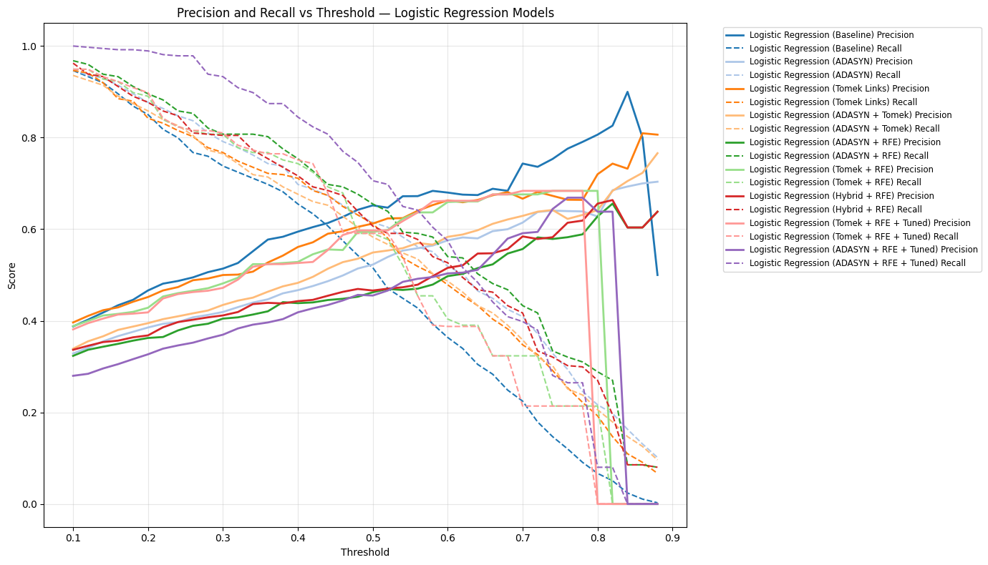

import numpy as np  
  
thresholds = np.arange(0.1, 0.9, 0.02)  
proba = model_probs_lr["Logistic Regression (Tomek + RFE + Tuned)"]  
  
for t in thresholds:  
 preds = (proba >= t).astype(int)  
 positives = preds.sum()  
 print(f"Threshold {t:.2f}: Predicted Positives = {positives}")

Threshold 0.10: Predicted Positives = 931  
Threshold 0.12: Predicted Positives = 899  
Threshold 0.14: Predicted Positives = 862  
Threshold 0.16: Predicted Positives = 834  
Threshold 0.18: Predicted Positives = 818  
Threshold 0.20: Predicted Positives = 803  
Threshold 0.22: Predicted Positives = 702  
Threshold 0.24: Predicted Positives = 672  
Threshold 0.26: Predicted Positives = 659  
Threshold 0.28: Predicted Positives = 655  
Threshold 0.30: Predicted Positives = 642  
Threshold 0.32: Predicted Positives = 598  
Threshold 0.34: Predicted Positives = 558  
Threshold 0.36: Predicted Positives = 546  
Threshold 0.38: Predicted Positives = 546  
Threshold 0.40: Predicted Positives = 534  
Threshold 0.42: Predicted Positives = 526  
Threshold 0.44: Predicted Positives = 458  
Threshold 0.46: Predicted Positives = 378  
Threshold 0.48: Predicted Positives = 370  
Threshold 0.50: Predicted Positives = 370  
Threshold 0.52: Predicted Positives = 370  
Threshold 0.54: Predicted Positives = 327  
Threshold 0.56: Predicted Positives = 267  
Threshold 0.58: Predicted Positives = 221  
Threshold 0.60: Predicted Positives = 219  
Threshold 0.62: Predicted Positives = 219  
Threshold 0.64: Predicted Positives = 219  
Threshold 0.66: Predicted Positives = 179  
Threshold 0.68: Predicted Positives = 179  
Threshold 0.70: Predicted Positives = 117  
Threshold 0.72: Predicted Positives = 117  
Threshold 0.74: Predicted Positives = 117  
Threshold 0.76: Predicted Positives = 117  
Threshold 0.78: Predicted Positives = 117  
Threshold 0.80: Predicted Positives = 0  
Threshold 0.82: Predicted Positives = 0  
Threshold 0.84: Predicted Positives = 0  
Threshold 0.86: Predicted Positives = 0  
Threshold 0.88: Predicted Positives = 0

import matplotlib.pyplot as plt  
  
# Get predicted probabilities  
proba = model_probs_lr["Logistic Regression (Tomek + RFE + Tuned)"]  
  
plt.figure(figsize=(10, 6))  
plt.hist(proba, bins=30, color='skyblue', edgecolor='black')  
plt.axvline(0.34, color='green', linestyle='--', label='Threshold 0.34')  
plt.axvline(0.80, color='red', linestyle='--', label='Threshold 0.80')  
  
plt.title('Predicted Probability Distribution — Logistic Regression (Tomek + RFE + Tuned)')  
plt.xlabel('Predicted Probability for Churn')  
plt.ylabel('Number of Instances')  
plt.legend()  
plt.grid(alpha=0.3)  
plt.show()

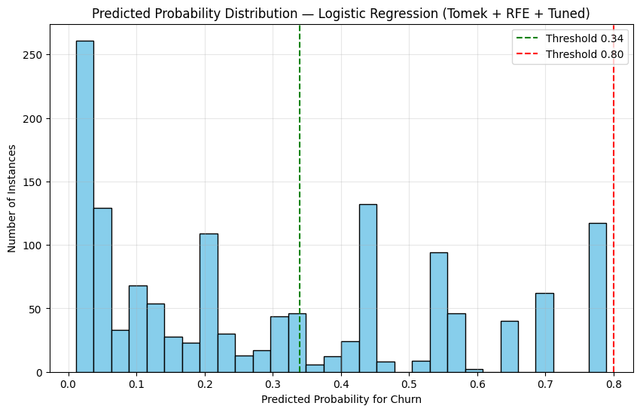

plot_precision_recall_vs_threshold(model_probs_rf, y_test, "Random Forest Models")

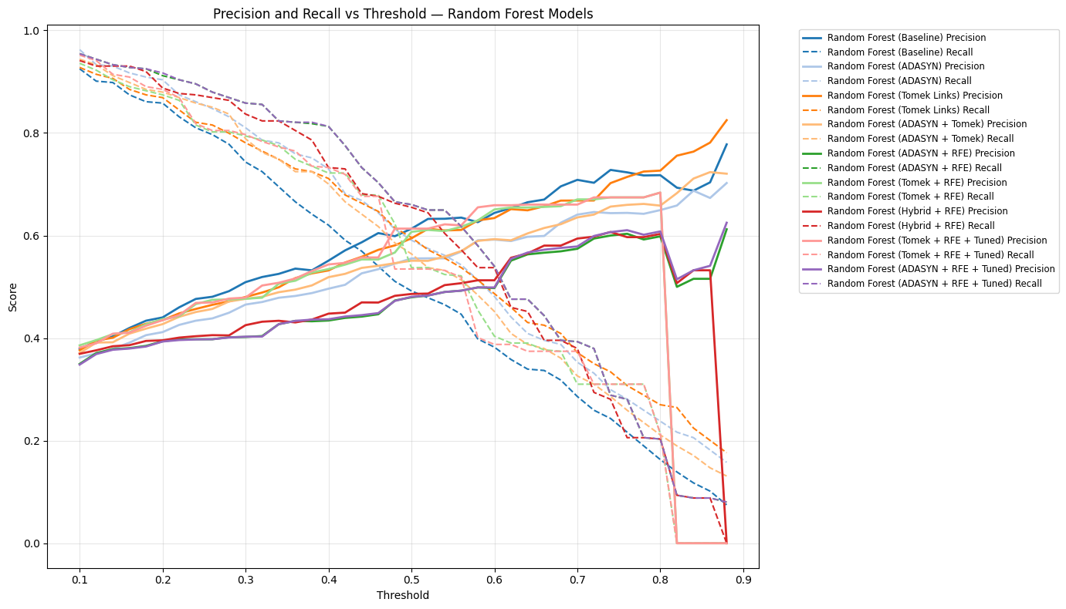

import numpy as np  
  
thresholds = np.arange(0.1, 0.9, 0.02)  
proba = model_probs_rf["Random Forest (Tomek + RFE + Tuned)"]  
  
for t in thresholds:  
 preds = (proba >= t).astype(int)  
 positives = preds.sum()  
 print(f"Threshold {t:.2f}: Predicted Positives = {positives}")

Threshold 0.10: Predicted Positives = 933  
Threshold 0.12: Predicted Positives = 903  
Threshold 0.14: Predicted Positives = 837  
Threshold 0.16: Predicted Positives = 828  
Threshold 0.18: Predicted Positives = 785  
Threshold 0.20: Predicted Positives = 761  
Threshold 0.22: Predicted Positives = 731  
Threshold 0.24: Predicted Positives = 653  
Threshold 0.26: Predicted Positives = 641  
Threshold 0.28: Predicted Positives = 631  
Threshold 0.30: Predicted Positives = 622  
Threshold 0.32: Predicted Positives = 583  
Threshold 0.34: Predicted Positives = 569  
Threshold 0.36: Predicted Positives = 554  
Threshold 0.38: Predicted Positives = 518  
Threshold 0.40: Predicted Positives = 504  
Threshold 0.42: Predicted Positives = 492  
Threshold 0.44: Predicted Positives = 454  
Threshold 0.46: Predicted Positives = 454  
Threshold 0.48: Predicted Positives = 326  
Threshold 0.50: Predicted Positives = 326  
Threshold 0.52: Predicted Positives = 326  
Threshold 0.54: Predicted Positives = 320  
Threshold 0.56: Predicted Positives = 313  
Threshold 0.58: Predicted Positives = 229  
Threshold 0.60: Predicted Positives = 220  
Threshold 0.62: Predicted Positives = 220  
Threshold 0.64: Predicted Positives = 212  
Threshold 0.66: Predicted Positives = 212  
Threshold 0.68: Predicted Positives = 212  
Threshold 0.70: Predicted Positives = 212  
Threshold 0.72: Predicted Positives = 172  
Threshold 0.74: Predicted Positives = 172  
Threshold 0.76: Predicted Positives = 172  
Threshold 0.78: Predicted Positives = 172  
Threshold 0.80: Predicted Positives = 117  
Threshold 0.82: Predicted Positives = 0  
Threshold 0.84: Predicted Positives = 0  
Threshold 0.86: Predicted Positives = 0  
Threshold 0.88: Predicted Positives = 0

import matplotlib.pyplot as plt  
  
# Get predicted probabilities  
proba = model_probs_rf["Random Forest (Tomek + RFE + Tuned)"]  
  
plt.figure(figsize=(10, 6))  
plt.hist(proba, bins=30, color='skyblue', edgecolor='black')  
plt.axvline(0.34, color='green', linestyle='--', label='Threshold 0.34')  
plt.axvline(0.80, color='red', linestyle='--', label='Threshold 0.80')  
  
plt.title('Predicted Probability Distribution — Random Forest (Tomek + RFE + Tuned)')  
plt.xlabel('Predicted Probability for Churn')  
plt.ylabel('Number of Instances')  
plt.legend()  
plt.grid(alpha=0.3)  
plt.show()

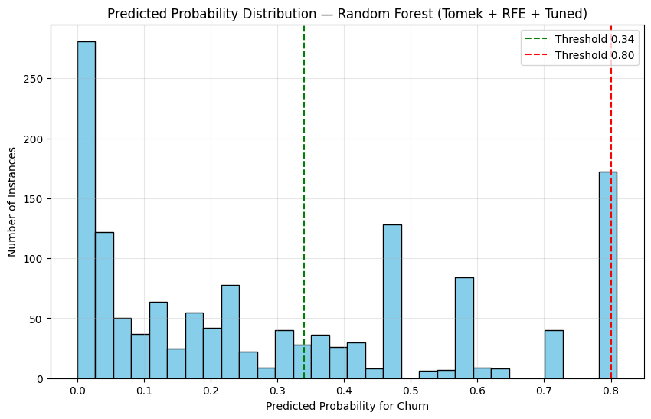

from sklearn.metrics import roc_curve, auc  
import matplotlib.pyplot as plt  
  
def plot_roc_curves(model_probs, y_test, title):  
 plt.figure(figsize=(14, 8)) # SAME SIZE as Precision-Recall  
  
 colors = plt.get_cmap('tab20').colors  
 color_idx = 0  
  
 for model_name, y_proba in model_probs.items():  
 fpr, tpr, _ = roc_curve(y_test, y_proba)  
 roc_auc = auc(fpr, tpr)  
  
 color = colors[color_idx % len(colors)]  
  
 plt.plot(fpr, tpr, color=color, lw=2,  
 label=f'{model_name} (AUC = {roc_auc:.3f})')  
  
 color_idx += 1  
  
 plt.plot([0, 1], [0, 1], color='gray', linestyle='--', lw=1)  
 plt.xlim([0.0, 1.0])  
 plt.ylim([0.0, 1.05])  
 plt.xlabel('False Positive Rate')  
 plt.ylabel('True Positive Rate')  
 plt.title(f'ROC Curves — {title}')  
  
 # Legend matches PR plot  
 plt.legend(bbox_to_anchor=(1.05, 1), loc='upper left', fontsize='small')  
  
 plt.grid(alpha=0.3)  
 plt.tight_layout()  
 plt.show()

plot_roc_curves(model_probs_lr, y_test, "Logistic Regression Models")

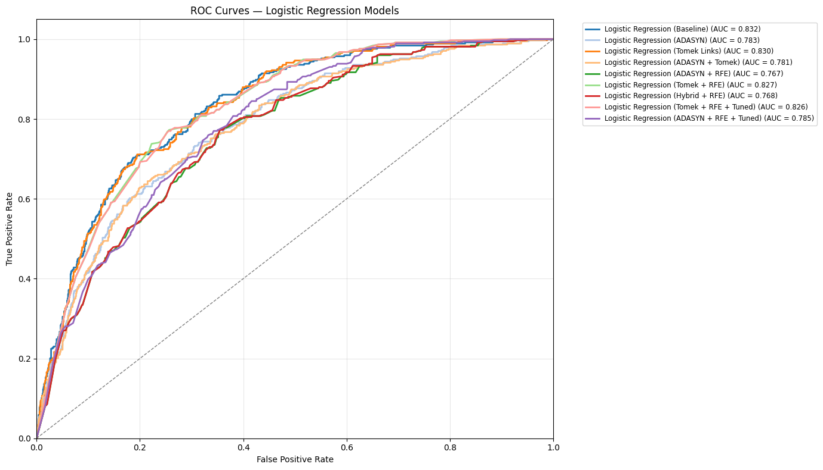

plot_roc_curves(model_probs_rf, y_test, "Random Forest Models")

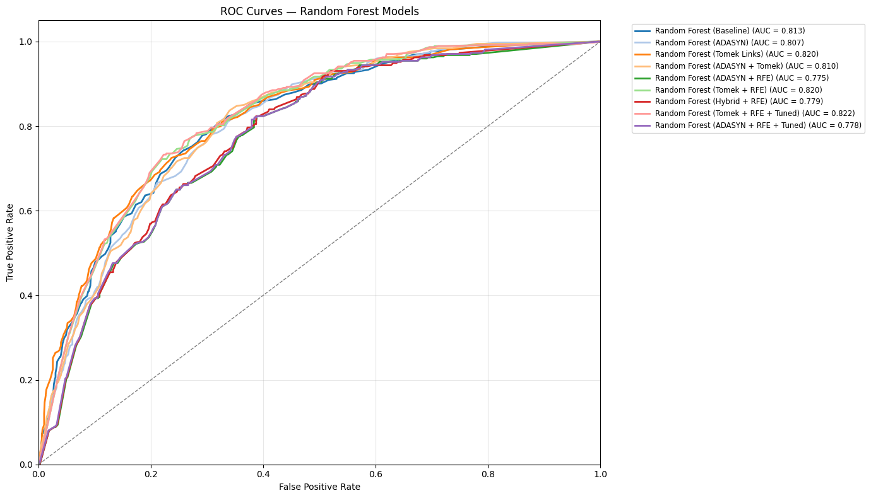

from sklearn.calibration import calibration_curve  
import matplotlib.pyplot as plt  
  
def plot_calibration_curves(model_probs, y_test, title):  
 plt.figure(figsize=(14, 8))  
  
 colors = plt.get_cmap('tab20').colors  
 color_idx = 0  
  
 for model_name, y_proba in model_probs.items():  
 prob_true, prob_pred = calibration_curve(y_test, y_proba, n_bins=10)  
  
 color = colors[color_idx % len(colors)]  
  
 plt.plot(prob_pred, prob_true, marker='o', linewidth=2, color=color,  
 label=f'{model_name}')  
  
 color_idx += 1  
  
 plt.plot([0, 1], [0, 1], "k--", label="Perfect Calibration")  
 plt.xlabel('Mean Predicted Probability')  
 plt.ylabel('Fraction of Positives')  
 plt.title(f'Calibration Curves — {title}')  
 plt.legend(bbox_to_anchor=(1.05, 1), loc='upper left', fontsize='small')  
 plt.grid(alpha=0.3)  
 plt.tight_layout()  
 plt.show()

plot_calibration_curves(model_probs_lr, y_test, "Logistic Regression Models")

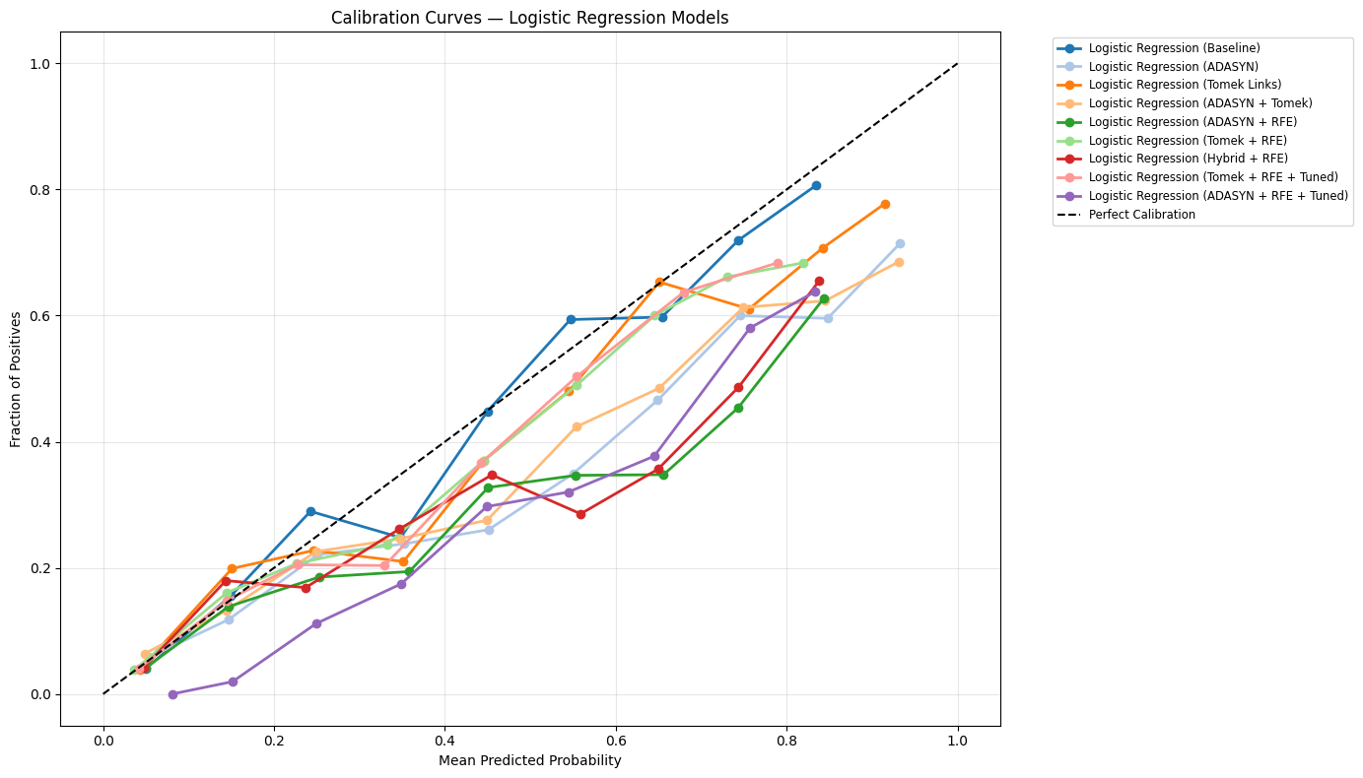

plot_calibration_curves(model_probs_rf, y_test, "Random Forest Models")

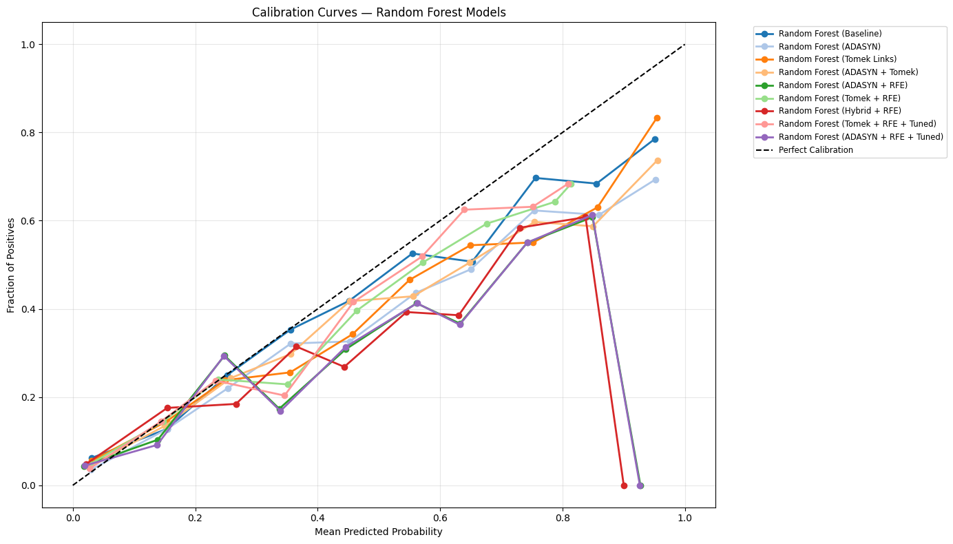

import numpy as np  
import matplotlib.pyplot as plt  
from sklearn.metrics import confusion_matrix  
  
# Your existing predicted probabilities  
y_proba = model_probs_lr["Logistic Regression (Tomek + RFE + Tuned)"]  
  
# Define threshold range  
thresholds = np.arange(0.3, 0.71, 0.01)  
  
# Cost settings  
cost_fn = 500 # False Negative cost (missed churner)  
cost_fp = 50 # False Positive cost (unnecessary retention)  
  
total_costs = []  
  
for thresh in thresholds:  
 y_pred = (y_proba >= thresh).astype(int)  
 tn, fp, fn, tp = confusion_matrix(y_test, y_pred).ravel()  
 total_cost = (fn * cost_fn) + (fp * cost_fp)  
 total_costs.append(total_cost)  
  
# Plotting  
plt.figure(figsize=(10, 6))  
plt.plot(thresholds, total_costs, marker='o', color='blue')  
plt.xlabel('Threshold')  
plt.ylabel('Total Cost ($)')  
plt.title('Cost vs Threshold — Logistic Regression (Tomek + RFE + Tuned)')  
plt.grid(alpha=0.3)  
plt.show()  
  
# Display the threshold with minimum cost  
min_cost_idx = np.argmin(total_costs)  
print(f"Optimal threshold (min cost): {thresholds[min_cost_idx]:.2f}")  
print(f"Minimum total cost: ${total_costs[min_cost_idx]:,.2f}")

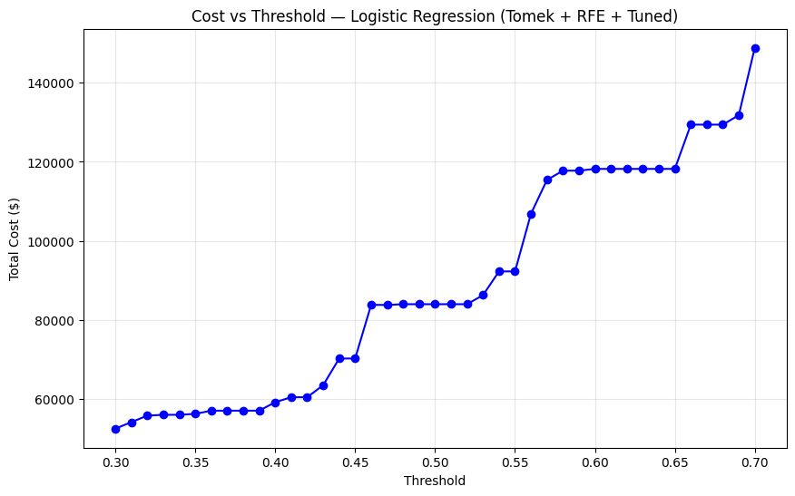

Optimal threshold (min cost): 0.30  
Minimum total cost: $52,450.00

# Get the predicted probabilities for Random Forest (ADASYN + RFE + Tuned)  
y_proba_rf = model_probs_rf["Random Forest (ADASYN + RFE + Tuned)"]  
  
# Thresholds to evaluate  
thresholds = np.arange(0.3, 0.71, 0.01)  
  
# Costs (same as before)  
cost_fn = 500 # False Negative  
cost_fp = 50 # False Positive  
  
total_costs_rf = []  
  
for thresh in thresholds:  
 y_pred_rf = (y_proba_rf >= thresh).astype(int)  
 tn, fp, fn, tp = confusion_matrix(y_test, y_pred_rf).ravel()  
 total_cost = (fn * cost_fn) + (fp * cost_fp)  
 total_costs_rf.append(total_cost)  
  
# Plotting  
plt.figure(figsize=(10, 6))  
plt.plot(thresholds, total_costs_rf, marker='o', color='darkgreen')  
plt.xlabel('Threshold')  
plt.ylabel('Total Cost ($)')  
plt.title('Cost vs Threshold — Random Forest (ADASYN + RFE + Tuned)')  
plt.grid(alpha=0.3)  
plt.show()  
  
# Minimum cost and corresponding threshold  
min_cost_idx_rf = np.argmin(total_costs_rf)  
print(f"Optimal threshold (min cost): {thresholds[min_cost_idx_rf]:.2f}")  
print(f"Minimum total cost: ${total_costs_rf[min_cost_idx_rf]:,.2f}")

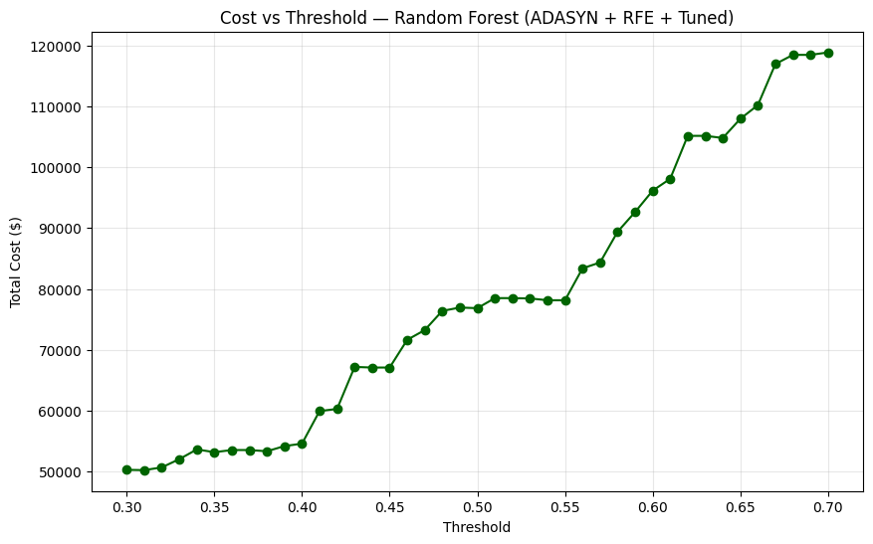

Optimal threshold (min cost): 0.31  
Minimum total cost: $50,250.00

# FN cost range  
fn_costs = np.arange(300, 701, 50) # 300 to 700 in steps of 50  
fp_cost = 50  
  
# Best thresholds identified earlier  
best_thresh_lr = 0.34  
best_thresh_rf = 0.34  
  
# Store total costs for each FN cost  
costs_lr = []  
costs_rf = []  
  
for fn in fn_costs:  
 # Logistic Regression  
 y_pred_lr = (model_probs_lr["Logistic Regression (Tomek + RFE + Tuned)"] >= best_thresh_lr).astype(int)  
 tn, fp_lr, fn_lr, tp = confusion_matrix(y_test, y_pred_lr).ravel()  
 total_cost_lr = (fn_lr * fn) + (fp_lr * fp_cost)  
 costs_lr.append(total_cost_lr)  
  
 # Random Forest  
 y_pred_rf = (model_probs_rf["Random Forest (ADASYN + RFE + Tuned)"] >= best_thresh_rf).astype(int)  
 tn, fp_rf, fn_rf, tp = confusion_matrix(y_test, y_pred_rf).ravel()  
 total_cost_rf = (fn_rf * fn) + (fp_rf * fp_cost)  
 costs_rf.append(total_cost_rf)  
  
# Plotting  
plt.figure(figsize=(10, 6))  
plt.plot(fn_costs, costs_lr, marker='o', label='Logistic Regression (Tomek + RFE + Tuned)', color='blue')  
plt.plot(fn_costs, costs_rf, marker='o', label='Random Forest (ADASYN + RFE + Tuned)', color='darkgreen')  
plt.xlabel('False Negative Cost ($)')  
plt.ylabel('Total Cost ($)')  
plt.title('Sensitivity Analysis: Total Cost vs. False Negative Cost')  
plt.legend()  
plt.grid(alpha=0.3)  
plt.show()

